# **dim_fulfillment**

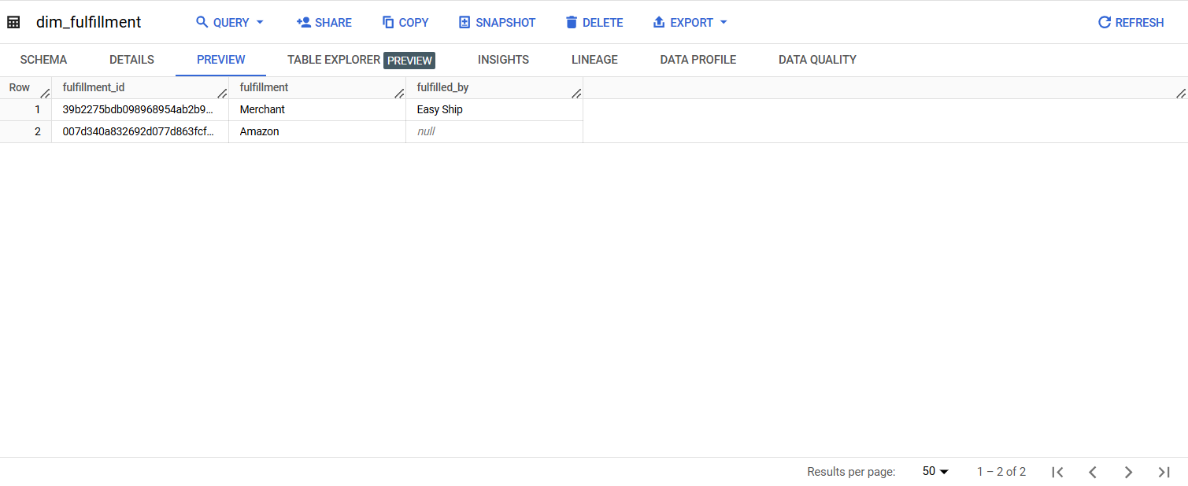

# **dim_product**

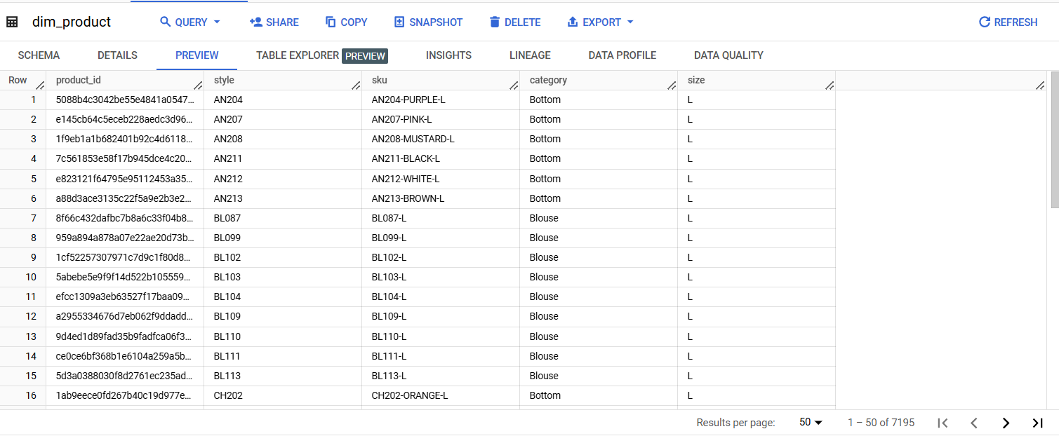

# **dim_promotion**

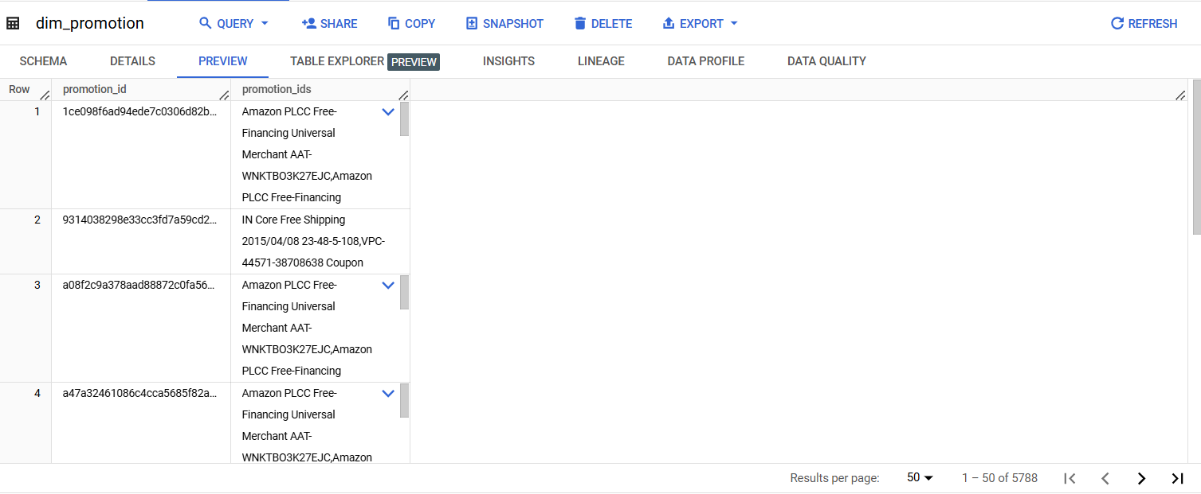

# **fact_sales**

# 

# 

# **dim_sales_channel**

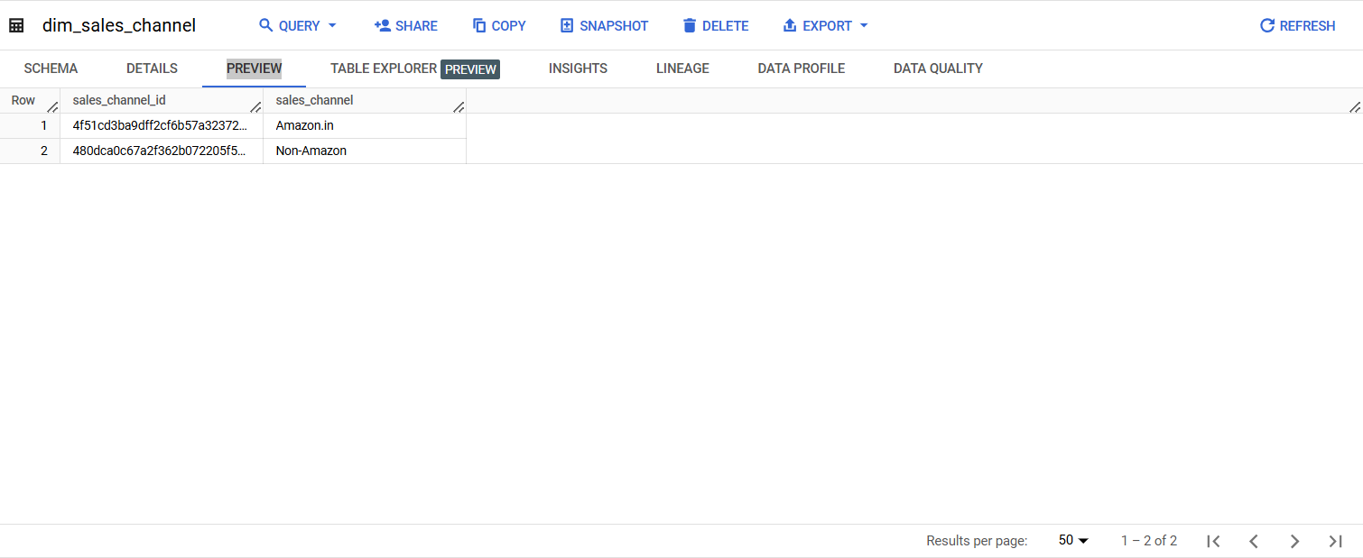

# 

# **dim_sales_shipment**

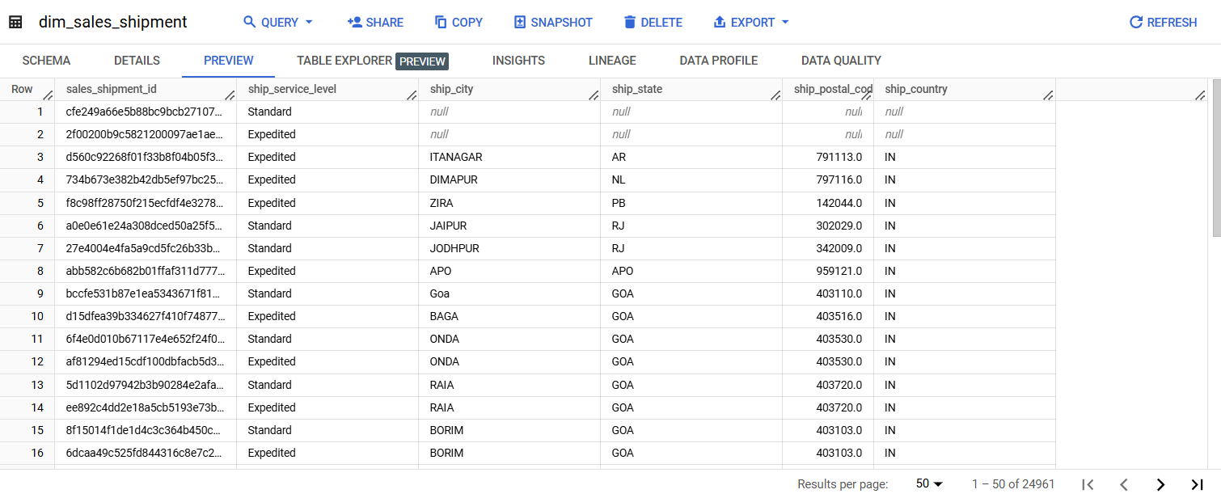

# 

# **fact_salesorder**

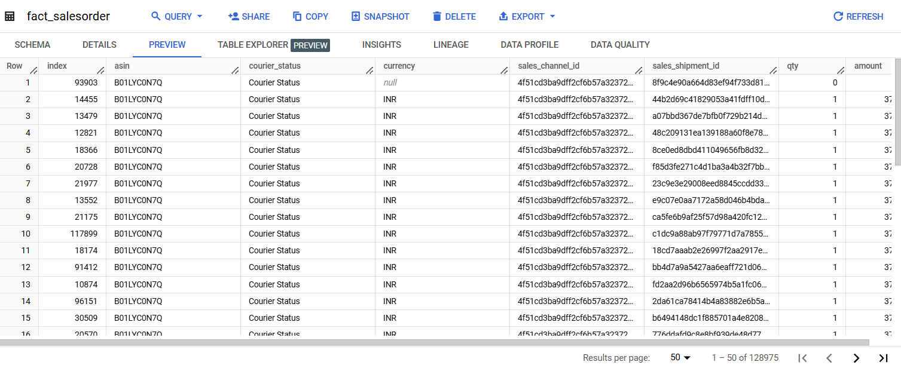

# **Query Analyzer**

**select last_day(fs.date) period**

**, sum(fs.qty) qty**

**, sum(case when fs.status like 'Ship%' then fs.amount else 0 end) amt_ship**

**, sum(case when fs.status like 'Cancelled%' then fs.amount else 0 end) amt_cancelled**

**, sum(case when fs.status like 'Pending%' then fs.amount else 0 end) amt_pending**

**, sum(fs.amount) amt_total**

**from `dibimbing.fact_sales` fs**

**left join `dibimbing.dim_product` dp on fs.product_id = dp.product_id**

**where dp.size = '3XL'**

**group by all**

**order by 1;**

